23.12.2008
90 minutes
CSE221 DIGITAL LOGIC FUNDAMENTALS
MIDTERM EXAM

(15) |  | The following Boolean function (with its don't-cares) is given:  F (P,Q,R,S) = Σm (2, 4, 6, 7, 11, 14) d (P,Q,R,S) = Σm (1,3, 9, 10, 12, 15)  - Using Karnaugh map method, find and write the most simplified Boolean expression as sum-of-products and product-of-sums for this Boolean function.  - Draw the combinational circuit for this function using as few NAND gates as possible.
(10) |  | Implement the following function using an 4-to-1 multiplexer. Show your design by drawing a clearly labeled circuit diagram. Is it possible to do with one selection multiplexers?  X= A’B’C + A’B C’ + A B’C + A B C’
(10) |  | Show the decimal equivalent of each of the numbers if they are interpreted as
   | 1 0 0 1 0 1 1 0 | 0 0 1 0 0 1 0 1
  Signed-magnitude system
  1’s complement system
  2’s complement system
  Gray code
  BCD code
(10) |  | Implement the F function using a 3:8 decoder with an OR gate. Is it possible to do with 2:4 decoder shown below?  F(A,B,C)=ABC + AB’C + AC  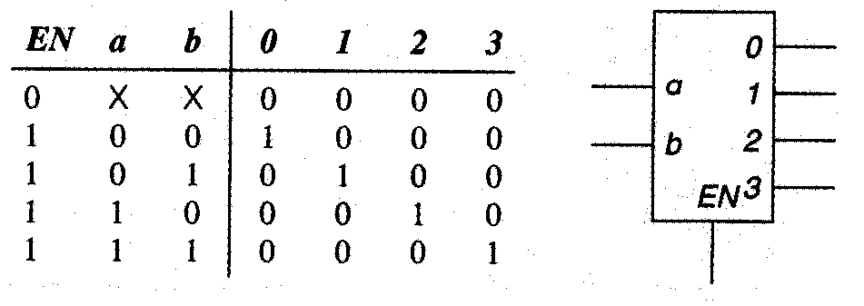
(9) |  | Give 3 advantages of digital systems over analog systems
(10) |  | Convert the decimal number – 1.02325 x 10 ³ to a single-precision floating-point binary number
(15) |  | Draw the output waveforms ( G₂, G₃, and X ) for the following logic diagram. Find the maximum propagation delay for this circuit. Assume each gate has a propagation delay of 5 ns.  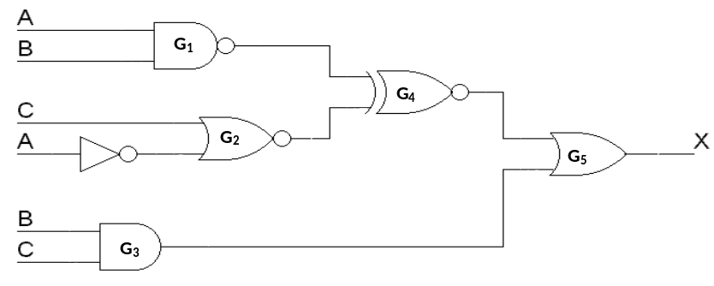  A  B  C  G₂  X  G₁  G₄  G₃
(9) |  | Convert the decimal number 247.1875 to  - binary,  - hexadecimal,  - octal,
(12) |  | Perform the following arithmetic operation for binary numbers 10000011 and 00110010 without converting to decimal. The binary numbers listed have a sign in the left most position and, if negative, are in 2’s complement form. Find decimal equivalents of the results.  - Multiplication ( 16 bits result)  - Division ( 4 bits result)

